Ride the Ruby Country Devon County Council update

Works are almost complete on the bridleway that leads from Beaworthy to Dreybury Lane (which then leads in to Halwill Junction). One job needs finishing – to improve the drainage at the Beaworthy end. The route remains fully useable and will form part of the Pegasus Way, being a long distance horse-riding route which will connect Dartmoor with Cookworthy Forest primarily using a dismantled railway track and minor roads. I am planning to set up a webpage on www.devon.gov.uk/prow dedicated to the Pegasus Way. This will include a map of the existing section of the route and will also provide space for updates on future developments.

Improvement works are due for completion this week at Lower Melbury. This is a diversion of the existing bridleway through the farm, including the installation of a new bridle bridge across the stream. The works will make the route much easier to use.

The new bridleway linking Halwill to Cookworthy Forest has passed its final safety audit and is fully open to the public. This makes use of a dismantled railway track, a farm track and a new section of track through the forestry to link to existing forest roads. It crosses the A3079 near Lane End Cross.

I will soon be starting the legal process to divert the public bridleway through the Northcombe Plantation onto one of the forest roads. This will include a new crossing point of the A3079 to take the public directly onto the minor road that leads to Beamsworthy. Currently the bridleway ends at a location on the A3079 which is not particularly suitable for walking, riding or cycling. The access onto the A road may require planning permission.

We are working towards producing a series of seven circular rides in the Ruby Country. Draft maps have been produced which will be discussed at the next Ruby Riders meeting on Thursday 18th August 2011 at the Cookworthy Forest Centre. Steve Gardner, Rights of Way Officer for Devon County Council, will be available all day if you want to chat about anything (preferably related to public rights of way(!)) with the formal meeting starting at 1.30pm. Everyone is welcome!

Photos to show the clearance and drainage works on the new bridleway from Halwill to Cookworthy Forest (photos taken roughly at same location)

July 2009 | February 2010 | July 2011
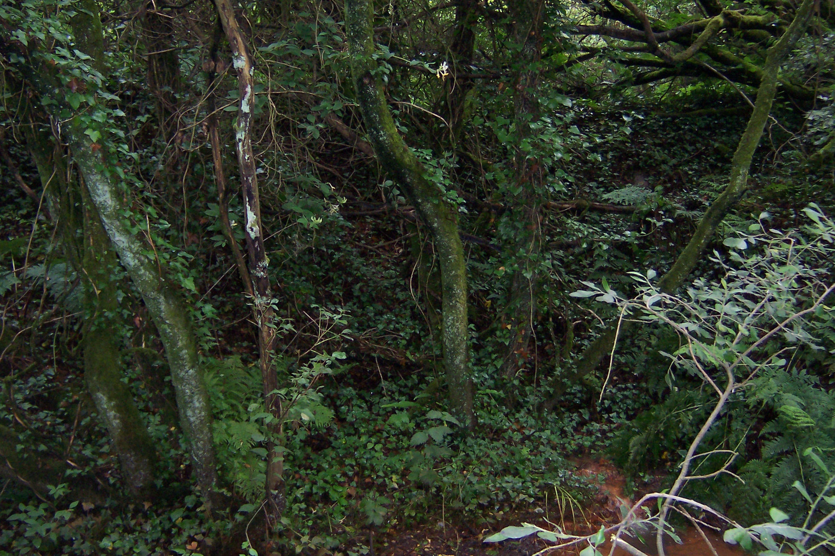 | 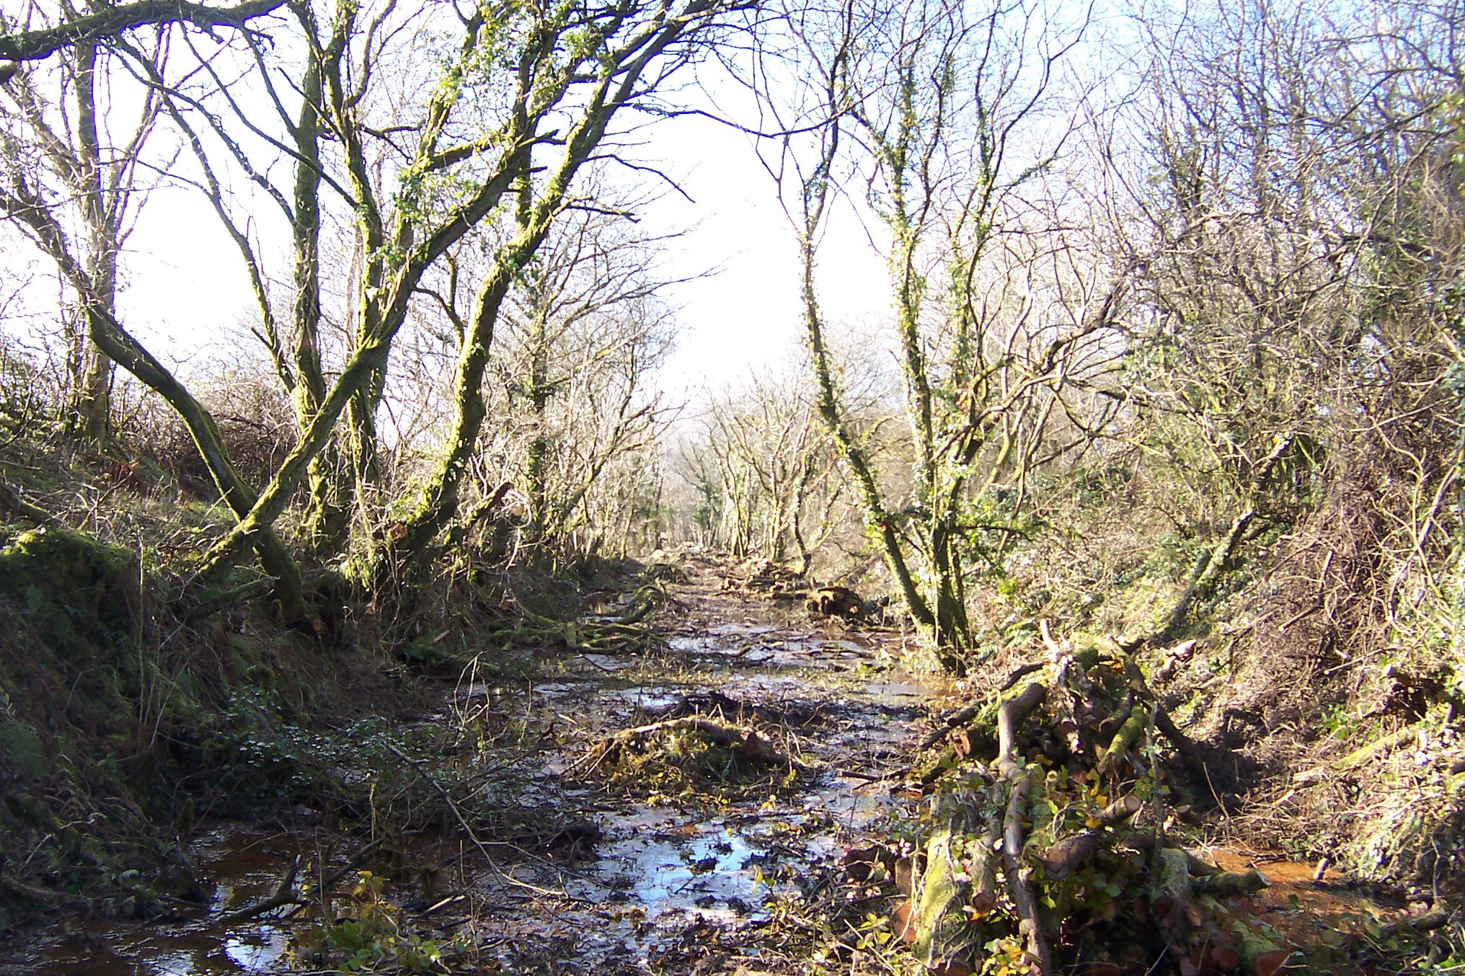 | 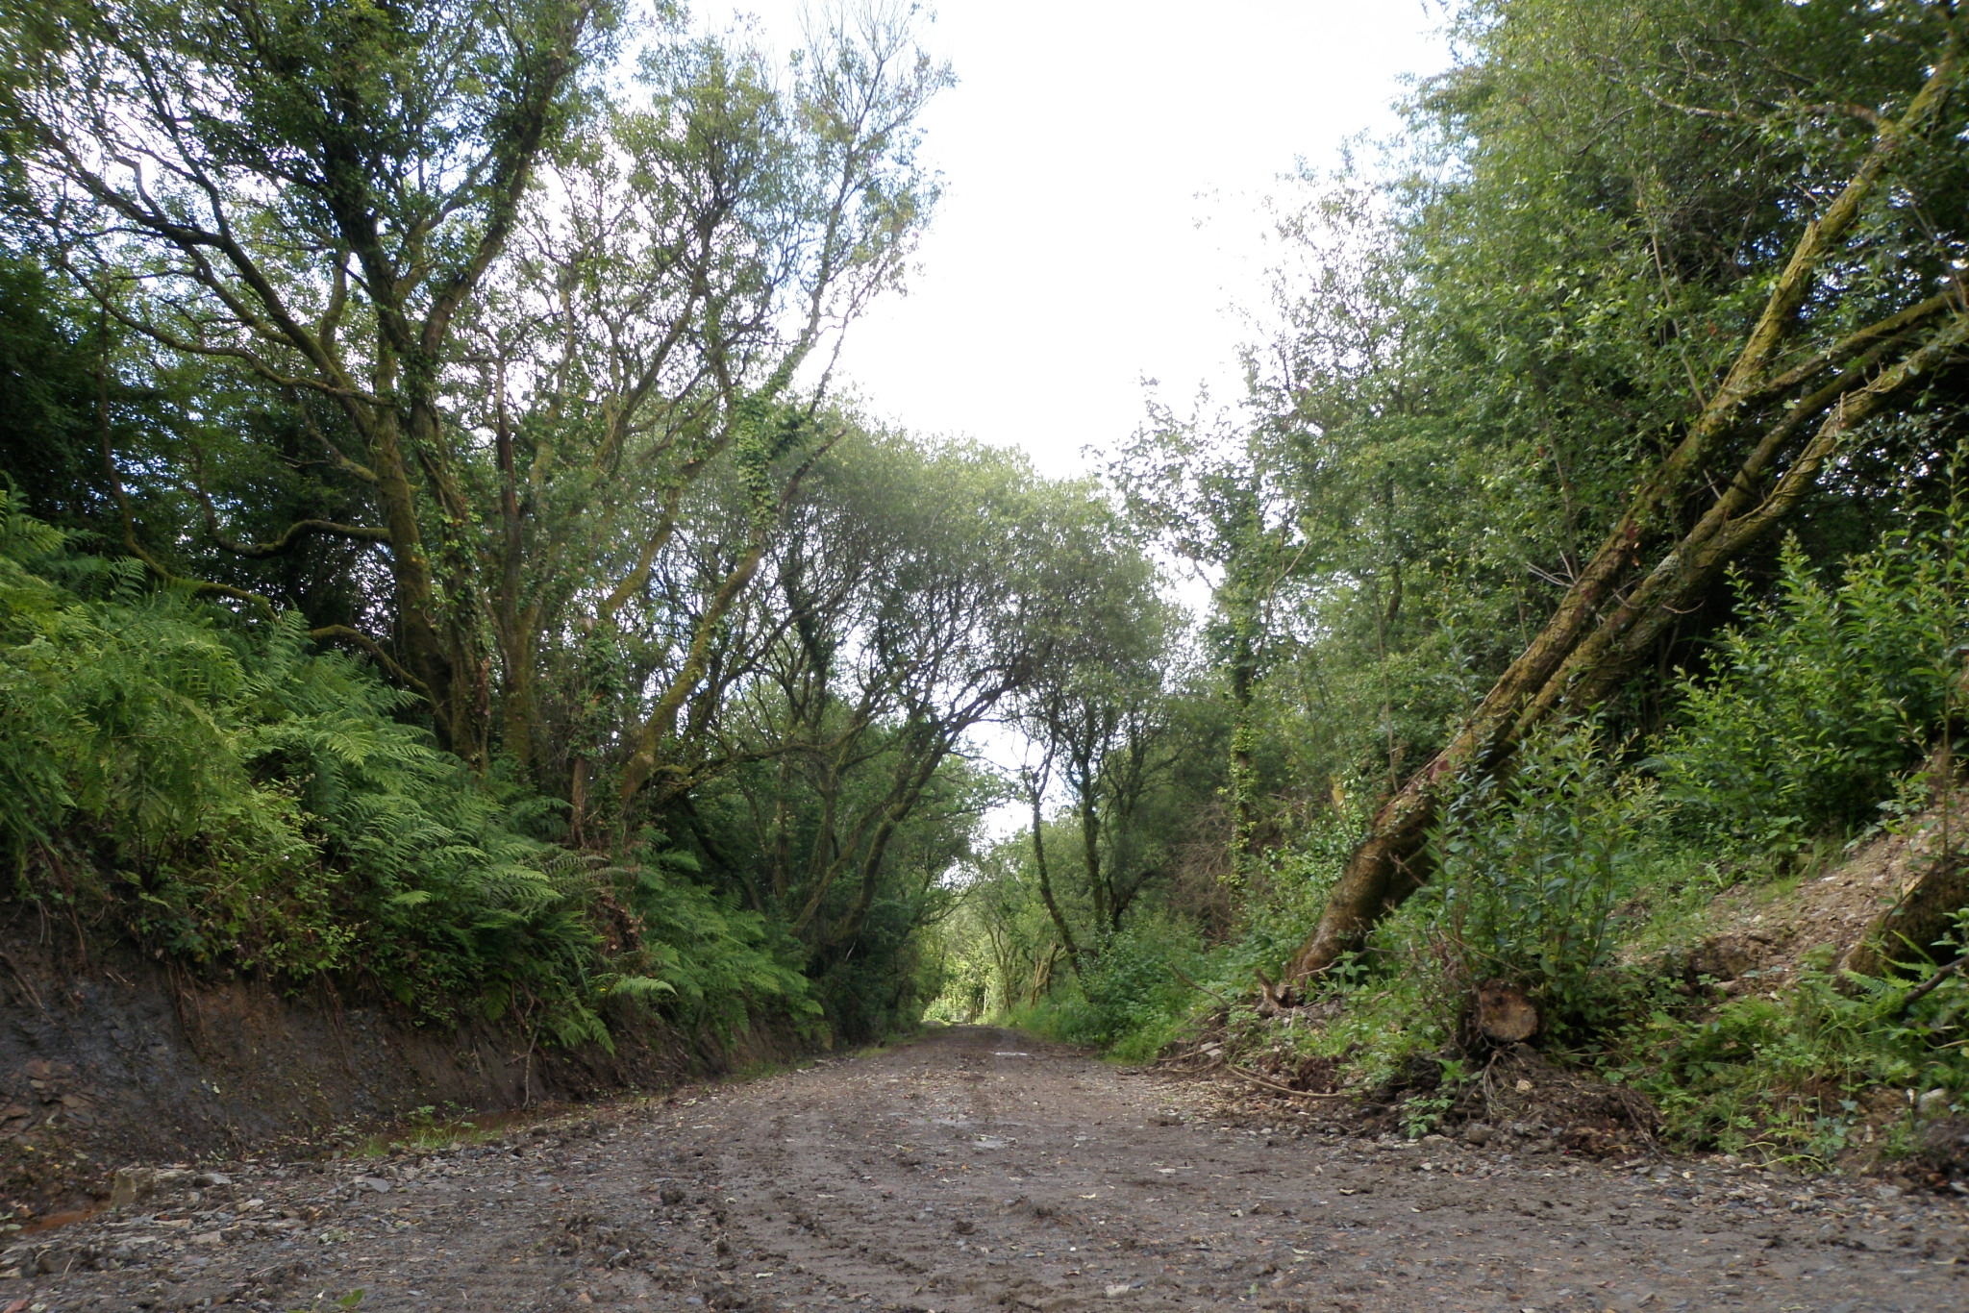

Steve Gardner, Public Rights of Way Officer, Devon County Council

